**Create a simple cloud software application for Hospital information system for SIMATS Hospital using any Cloud Service Provider to demonstrate SaaS with fields of patient name, age, address, phone, email, Attender name, attender phone, doctor name, diseases, etc.**

**AIM:**

Create a simple cloud software application for Property Buying & Rental process (In Chennai city) using any Cloud Service Provider

**PROCEDURE:**

**STEP 1:**

Open browser and get into zoho ceator. Then sign in and click “Create application”. Below given screenshot will appear, hear type the application name of your Aim.

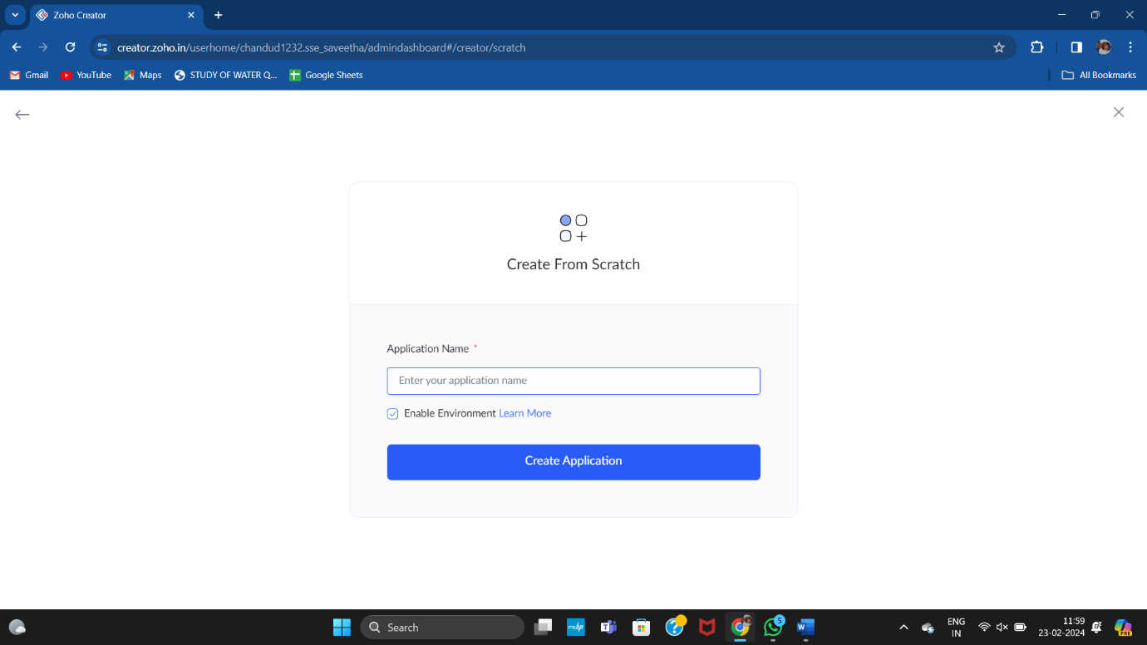

**STEP 2:**

Then select “start from scratch” option and select the proper component from the 4 components listed. For my application I just selected “forms” for the login credentials.

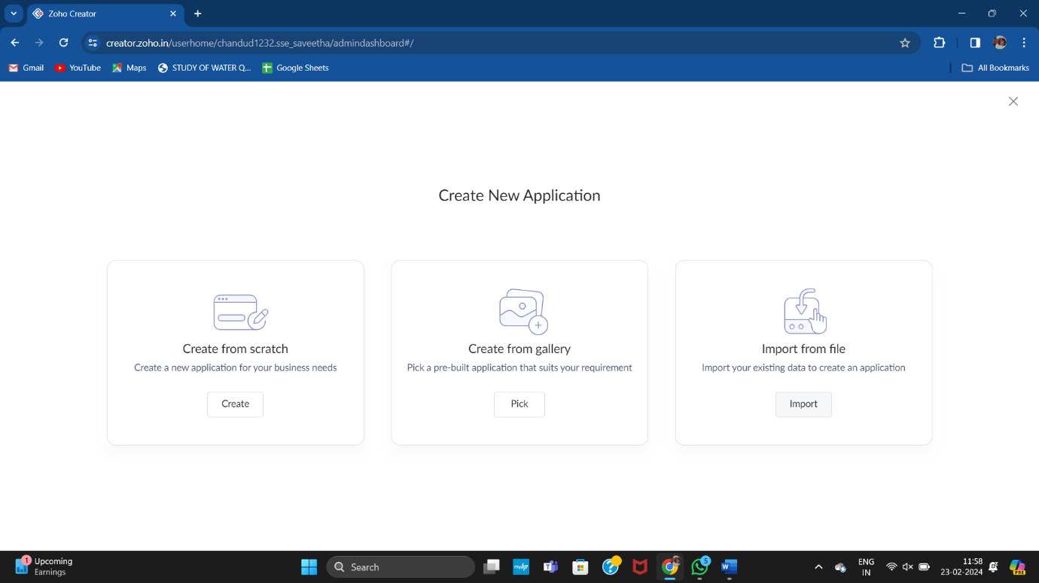

**STEP 3:**

In forms, below given options will be given. From here we can get sample templates of our requirements, otherwise we can import already saved schema for our application. I just selected “ from scratch” option for my application.

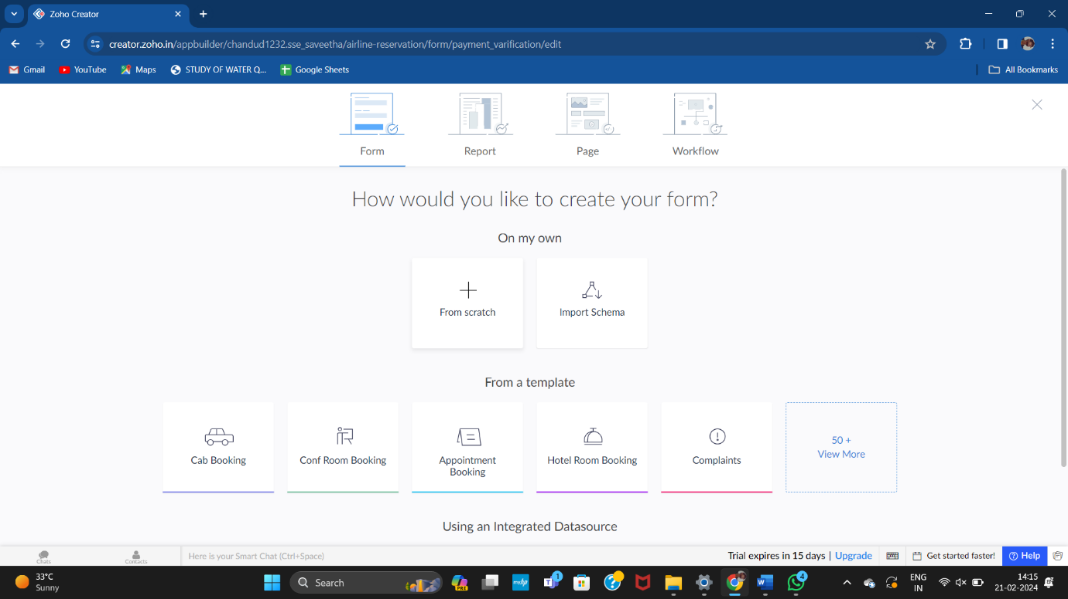

**STEP 4:**

Then provide an appropriate name for our application in the name form which shown below. I gave “EduHealth” for my “Hospital information system”

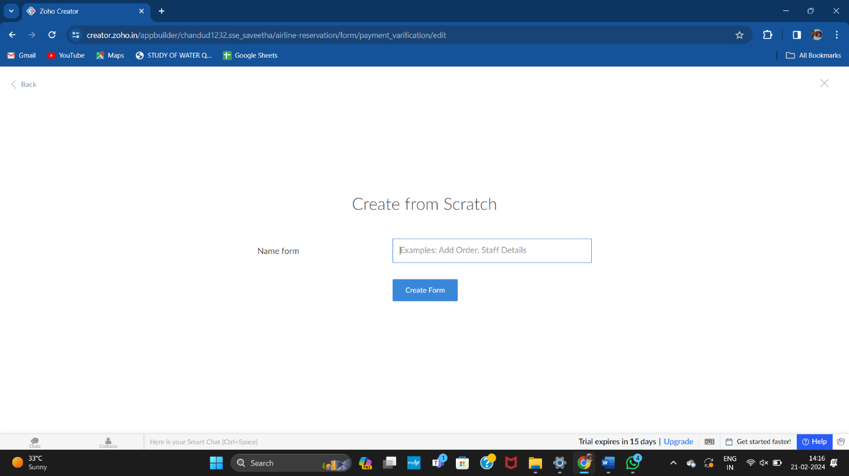

**STEP 5:**

by clicking “+” symbol shown in the picture given below, we can add number of forms in our application. Firstly I placed login form in my application with the essential credent

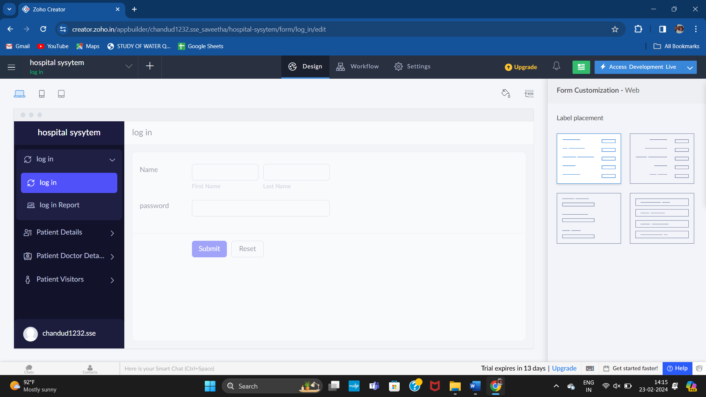

**STEP 6:**

Then I added another form namely “patient details”. It contains all the details poof the patient like personal and health issues.

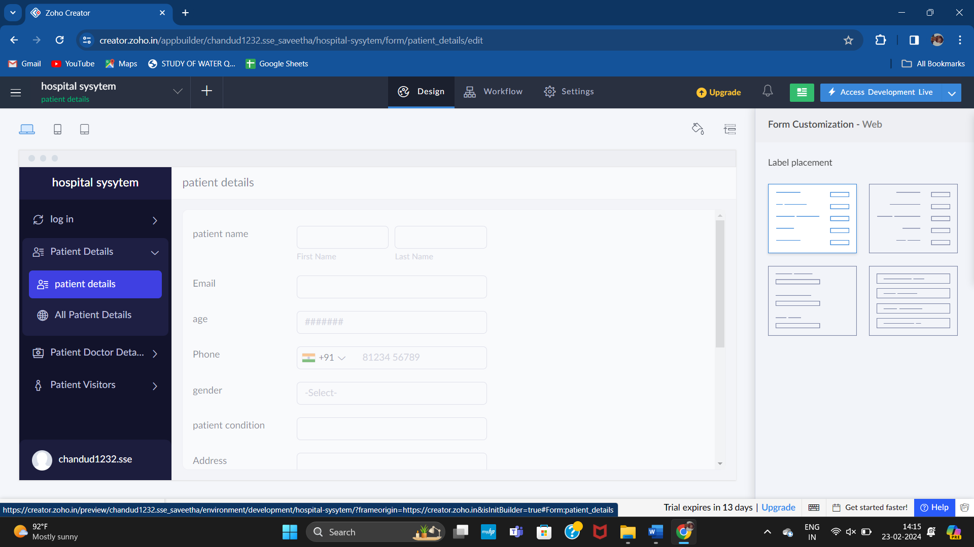

**STEP 7:**

Then I added another form namely “medical details,” which contains the details of his/her’s medical details .

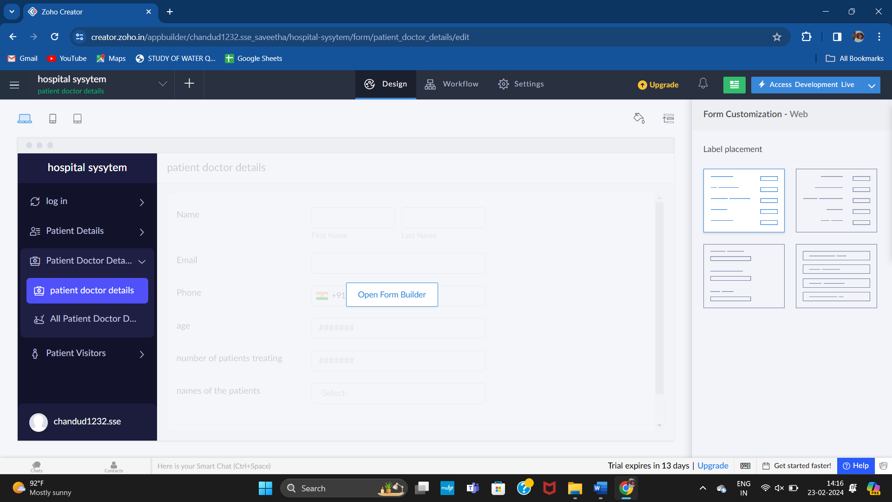

**STEP 8:**

Then in the next form I added “payments” of the selected thing. Here user can get the required data of payments and bill details of the treatment.



**STEP 9:**

In this form , the user/admin can logout with the essential credentials.

